1.HOW MANY LAYOUTS ARE THERE IN BOOTSTRAP?

2 LAYOUTS ARE THERE

* CONTAINER
* CONTAINER-FLUID

2.CONTAINER VS CONTAINER-FLUID

“CONTAINER” CLASS PROVIDES A FIXED WIDTH CONTAINER

“CONTAINER-FLUID” CLASS PROVIDES A FULL WIDTH CONTAINER

3.WHICH VERSION BOOTSTRAP YOU ARE USING

4

4.COMPONENTS

CARDS

SPINNERS

PAGINATION

JUMBOTORON

ALERTS

BUTTONS

5.

|  |  |
| --- | --- |
| BOOTSTRAP 3 | BOOTSTRAP 4 |
| BOOTSTRAP 3 BASED ON 4 TIER GRID SYSTEM | BOOTSTRAP 4 BASED ON 5 TIER GRID SYSTEM |
| BOOTSTRAP 3 SUPPORTS “PX” AS A CSS UNIT | BOOTSTRAP 4 SUPPORTS “REM” AS A CSS UNIT |
| FOR IMAGE RESPONSIVE WE WILL USE ‘IMG-RESPONSIVE’ CLASS IN BOOTSTRA 3 | FOR IMAGE RESPONSIVE WE WILL USE ‘IMG-FLUID’ CLASS IN BOOTSTRA 4 |
| BOOTSTRAP 3 FLEX IS NOT THERE | BOOTSTRAP 4 FLEX CLASSES AVAILBLE. |

6. GRID SYSTEM OR HOW TO ACHIEVE RESPONSIVE WEBDESIGN USING BOOTSTRAP.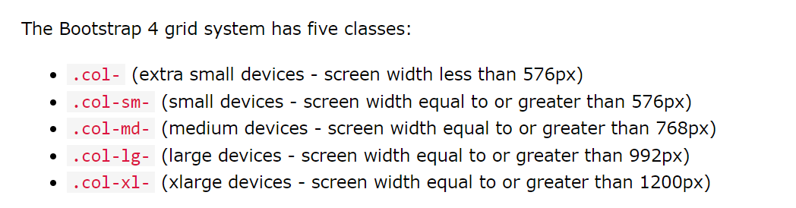

7.WHAT IS BOOTSTRAP

BOOTSTRAP IS CSS FRAMEWORK FOR DEVELOPING RESPONSIVE WEBSITES.IT INCLUDES HTML AND CSS BASED DESIGN TEMPLATES FOR TYPOGRAPHY, FORMS, BUTTONS, TABLES, NAVIGATION, MODALS, IMAGE CAROUSELS .

8.CURRENTLY WHICH VERSION IS THERE?

5

9.HOW TO SET “DISPLAY:NONE” USING BOOTSTRAP

**<h1 class=”d-none”>HTML</h1>**